

An-Najah-National-University

NetStrike: Enterprise Network Attack Simulation
Prepared by:
Amr Sharif & Oday AL Fakhoury
Supervised by:
Dr. Jihad Hamamreh
Course:
Computer Network

1. Introduction
This report presents the implementation of NetStrike, a small network simulation project built in GNS3 to demonstrate communication between multiple hosts through a routed network. The topology shown in the project includes a Kali Linux attacker machine, a web client machine, a switch, a router, and a server.
The main purpose of this topology is to simulate a simple network environment in which both a normal client and an attacker machine exist on the same local side of the network, while a remote server is placed on another side behind a router. This allows the project to demonstrate both legitimate client-to-server communication and basic attacker-side interaction with the target environment.
The topology is intentionally simple, but it reflects an important networking concept: devices on one subnet can access resources on another subnet only through proper routing and gateway configuration.

2. Problem Statement
In modern networks, multiple devices with different roles may exist in the same environment. Some devices act as legitimate clients that access services normally, while others may represent attacker systems used for scanning, testing, or reconnaissance. At the same time, servers hosting services are often placed on a different network segment for control and organization.
The challenge in this project is to build a basic but realistic topology in which:
- a web client can communicate with a remote server,
- a Kali Linux attacker can also interact with the same environment,
- and all communication passes through a router rather than staying in one flat LAN.
Without proper network design, IP configuration, and routing logic, the hosts would not be able to reach the server correctly.

3. Design Overview
The final topology shown in the project contains the following devices:
- Kali Linux machine (kali-1) acting as the attacker node
- Client machine (clinet_wep-1) acting as the legitimate web client
- Switch1 connecting the local devices together
- Router R1 routing traffic between the local network and the server network
- Server machine (server-1) acting as the destination server
The communication path in the network is:
Kali / Client → Switch1 → Router R1 → Server
This design creates a simple routed structure where the attacker and the client are located on one side of the network, while the server is located on another side.

4. Network Topology
The topology implemented in GNS3 is based on two main network segments:

User-side LAN
This segment includes:
- kali-1
- clinet_wep-1
- Switch1
These devices are connected together on the same local side of the network.

Server-side Network
This segment includes:
- server-1
The server is connected to Router R1, which separates it from the local user-side network.

Routing Device
- R1 acts as the central Layer 3 device that forwards packets between the user-side LAN and the server-side network.
This setup demonstrates a small but realistic client-server architecture with an additional attacker node.

5. IP Addressing Scheme
To ensure proper communication between all devices in the topology, a simple IP addressing scheme was assigned based on two main network segments: the user-side LAN and the server-side network.

User-side LAN
This subnet contains the local devices connected to Switch1, including the Kali Linux attacker and the web client.
- Network Address: 192.168.1.0/24
- Purpose: Hosts the attacker and client machines
- Default Gateway: 192.168.1.1

Server-side Network
This subnet contains the server machine connected on the other side of Router R1.
- Network Address: 192.168.2.0/24
- Purpose: Hosts the destination server
- Default Gateway: 192.168.2.1

Assigned IP Addresses
Device Name | Interface | IP Address | Subnet Mask | Default Gateway | Role
kali-1 | eth0 | 192.168.1.10 | 255.255.255.0 | 192.168.1.1 | Attacker machine
clinet_wep-1 | eth0 | 192.168.1.20 | 255.255.255.0 | 192.168.1.1 | Legitimate web client
R1 | f0/0 | 192.168.1.1 | 255.255.255.0 | N/A | Gateway for user-side LAN
R1 | f0/1 | 192.168.2.1 | 255.255.255.0 | N/A | Gateway for server-side network
server-1 | eth0 | 192.168.2.10 | 255.255.255.0 | 192.168.2.1 | Web/Application server
This addressing scheme ensures that both the client and the attacker machine can communicate with the router on the local subnet, while the router forwards traffic toward the server located on a separate subnet. The use of two different IP ranges reflects the routed design of the topology and demonstrates how inter-network communication depends on correct gateway assignment and routing
• GNS3 topology
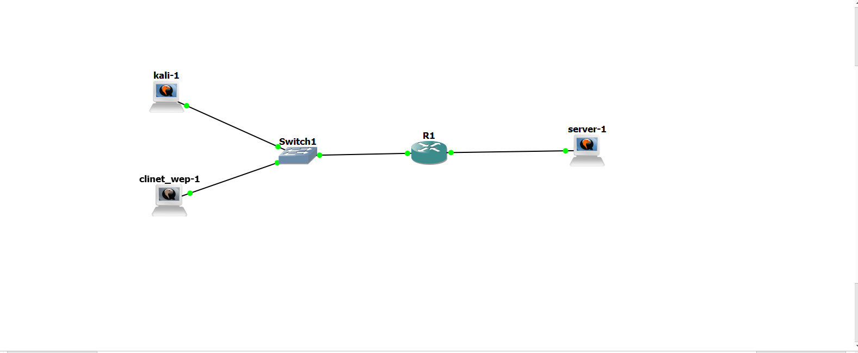
Figure (1): Final NetStrike topology inside GNS3.

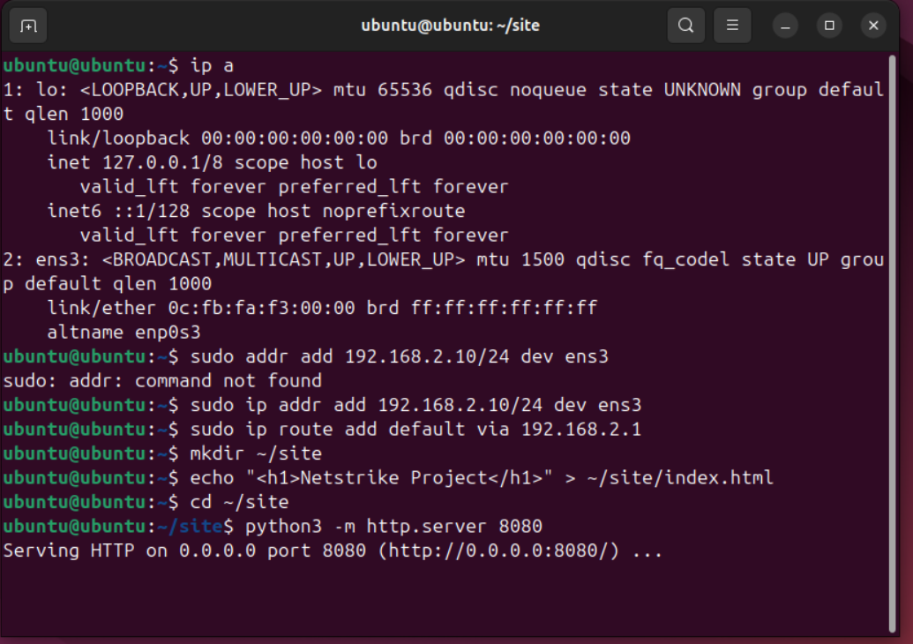Figure (2): Server IP configuration, default gateway assignment, and HTTP service startup.
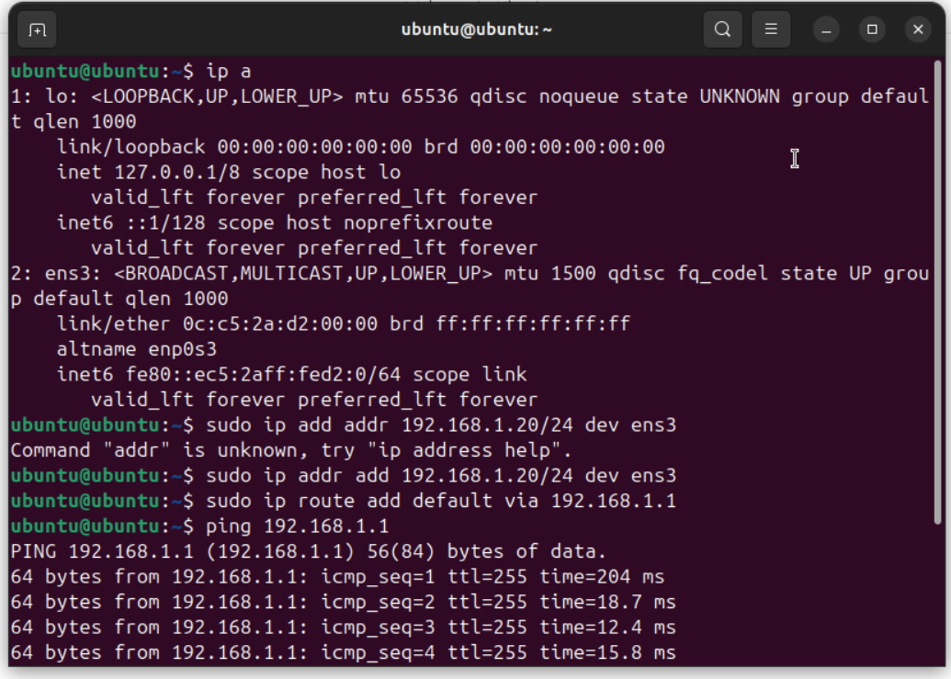Figure (3): Client IP address and default gateway configuration, followed by a successful connectivity test to the router.

6. Devices Used in the Project
The project contains the following devices:
- kali-1: attacker machine
- client_wep-1: legitimate web client
- Switch1: Layer 2 switch
- R1: router
- server-1: web/application server

7. Functional Role of Each Device

Kali Linux (kali-1)
This machine represents the attacker node in the topology. It is used for attacker-side testing such as:
- checking connectivity,
- testing reachability,
- performing basic scanning or reconnaissance,
- and observing the target server from a security perspective.

Client Machine (clinet_wep-1)
This device acts as the legitimate user endpoint. Its role is to access the remote server normally, such as through a browser or service request.

Switch1
The switch connects the Kali Linux machine and the client machine to the same local network and forwards frames between them and the router.

Router R1
R1 is the most important device in the topology because it performs routing between the local side of the network and the server side. It allows traffic from the client and attacker devices to reach the server.

Server (server-1)
The server acts as the destination machine in the topology. It may host a web service, application, or target resource that the client accesses and the attacker observes or tests.

8. Project Objective
The main objective of NetStrike is to simulate a simple routed environment where multiple hosts with different purposes interact with a remote server.
The project aims to demonstrate:
- normal communication between a client and a server,
- routed forwarding through a router,
- the role of a switch in local connectivity,
- and the presence of an attacker node in the same environment.
This makes the topology useful for understanding both basic networking and basic security-oriented simulation.

9. Testing and Verification
The project can be tested by verifying the following:
- connectivity between the client and the router,
- connectivity between Kali Linux and the router,
- connectivity from both hosts to the server,
- successful forwarding of traffic through R1,
- and proper response from the server.
Testing may include:
- ping tests,
- route verification,
- interface status checking,
- browser access from the client,
- and attacker-side probing from Kali Linux.
These tests confirm that the topology functions correctly and that all devices are interacting through the intended routed path.
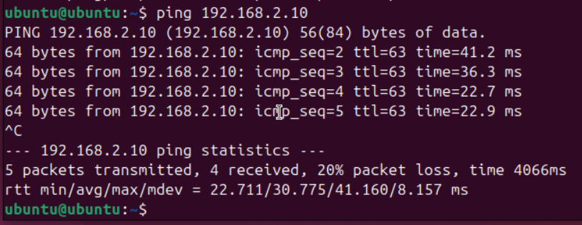Figure (4): Successful ping test from the client to the server through the router.
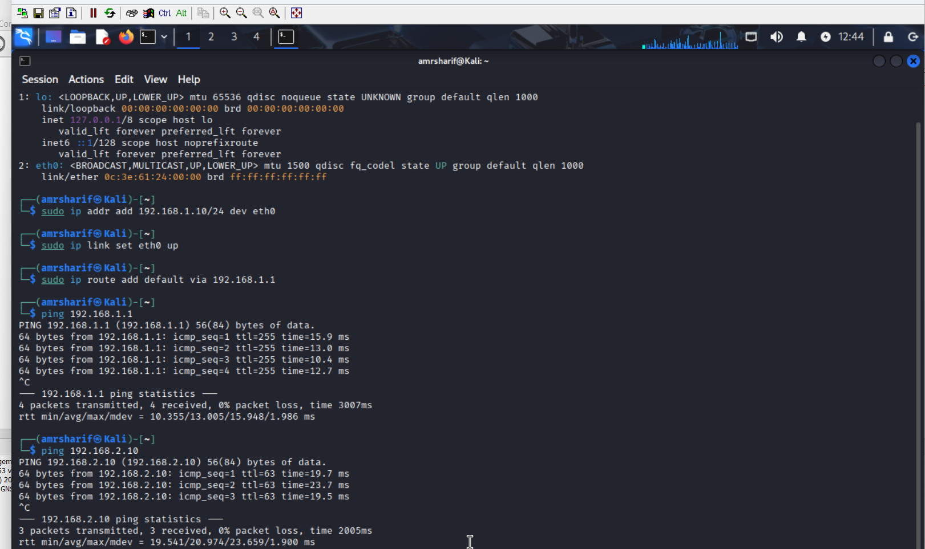Figure (5): Kali Linux configuration and successful reachability to the router and server.

10. Security Perspective
An important aspect of this topology is the addition of the Kali Linux machine. Unlike the normal client, Kali Linux represents a device that can be used for penetration testing or attacker simulation.
Its inclusion improves the project because it changes the topology from a simple client-server model into a more realistic environment where both normal and abnormal interactions may occur.
This allows the project to introduce the concept of:
- attacker presence in the network,
- reconnaissance activity,
- and comparison between legitimate user behavior and attacker behavior.
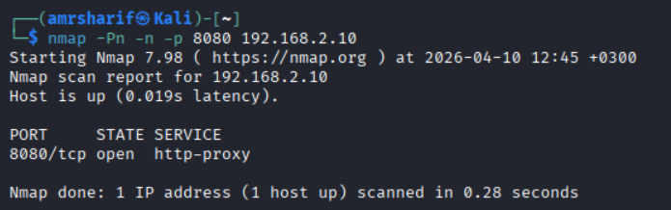Figure (6): Nmap scan showing that port 8080 is open on the server.

11. Results and Conclusion
The final GNS3 topology successfully demonstrates a basic routed network that includes a client, an attacker, a switch, a router, and a server.
The project proves that:
- multiple hosts can share the same local side of the network,
- a router can forward traffic toward a remote server,
- the client can represent normal service access,
- and Kali Linux can represent attacker-side observation and testing.
Although the topology is small, it reflects key networking principles such as:
- local switching,
- routing between networks,
- separation of roles among hosts,
- and the effect of adding an attacker device into a network design.
In conclusion, NetStrike provides a simple but effective simulation of a routed client-server environment with an attacker node, making it useful for both networking and introductory security demonstrations.
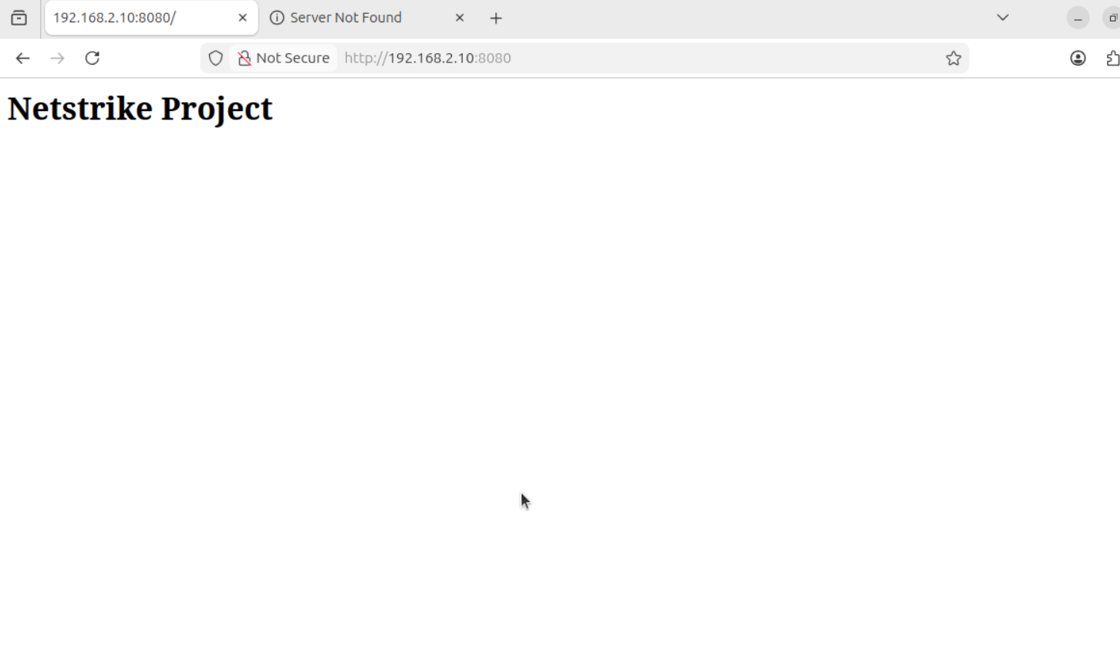Figure (7): Successful access to the hosted web page from the browser.

12. Final Note
This project is a practical example of how GNS3 can be used to simulate a network containing different types of endpoints. By combining a Kali Linux attacker, a legitimate client, a router, a switch, and a server, the topology represents a small but meaningful model of real-world communication and security testing.

